Meta Description:
1)Unearth Internal Linking Opportunities 2) Capitalize on Broken Links for Backlink Opportunities 3) Gain Credibility Through Testimonials 4) Craft Link-Worthy Content

9+1 Link-Building Strategies That Definitely Work in 2025
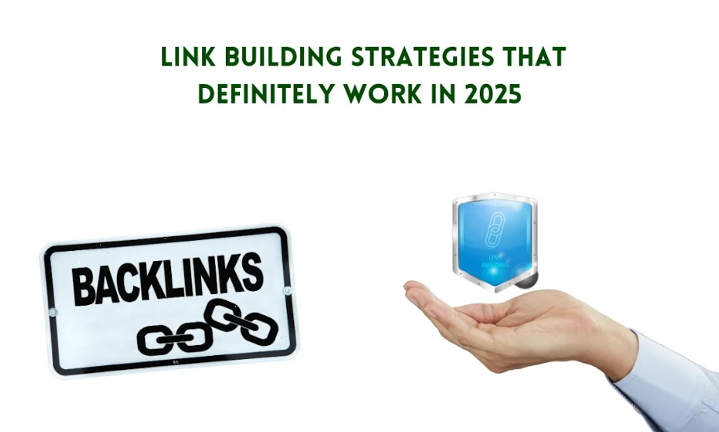
As we dive into the world of SEO, link building has remained one of the most important aspects of enhancing the online presence.
With the advancement in search algorithms, businesses need to rise to the occasion and come up with different ways to enhance the results more elaborately.
In this blog, we will put more emphasis on the importance of link-building when it comes to SEO. It is considered the essential component that will help your site gain better rankings in the search engine’s results list.
Here we will understand the link-building strategies that definitely work in 2025 but before that, we will learn what it is.

1. What is Link Building: Fundamentals and Beyond
In its simple form, link building is the process of obtaining hyperlinks from other websites that lead to your own site.
These links are important because they inform search engines that other web pages endorse your content, which in turn, boosts your website’s credibility.
This concept is similar to what is known as word-of-mouth advertising in the digital age.

The Evolution of Link-Building Practices:
The process of link building has become rather different from what it was several years ago when SEO started to gain popularity among webmasters.
Originally, link building was mainly focused on the number of links that were wanted, to garner as many links as possible.
However, search engines did not stay passive over this and they started to punish such sites that tried to employ fake links to manipulate for higher ranking.
Today, the issue is to create high-quality content that contains the link and is more relevant to the given material.

Link Building Role in Site Authority and Visibility:
Links from other authoritative websites improve the domain authority of your site and make it more likely to be ranked more often in the search engine result pages.
It is a clear advantage for the website as users are more likely to follow links placed at the top of SERP. In general, link building can be described as a focused effort to improve the SEO standing of your given website.

2. The Crucial Role of Link Building in SEO Success

How do Quality Links Impact Search Engine Rankings?
Link building for SEO is a major factor that influences search ranking on Google.
Typically, in the online environment, when the main authoritative sites link to your page, your content gains more credibility in the eyes of the search engines.
This could in turn cause better ranking, making the site more accessible to clients and visitors.

How Link Building Generates Traffic?
The links are not a dream of traffic but they are a line from the source to the creation of traffic.
The Internet offers the possibility to get links to other sites in various contexts to increase the conversion rate of the site in question.
This can also help to pick up the rate at which link-building takes place and create a positive feedback loop for the website.

The Long-Term Benefits of Building a Robust Link Profile:
Another motive to build a strong link profile is that they are long-term for SEO.
It is a matter of fact that regular link building can bring regular changes in ranking and terms of traffic as well.
Additionally, a good link profile adds a level of resistance to changes in algorithms and other forms of SEO fluctuations.

3. Dofollow vs. Nofollow Links: A Guide to Choosing Wisely
Dofollow links are the links that you get from other sites and they directly impact your rankings on search engine result pages.
They are perhaps the best way of link building.
On the other hand, links that do not permit the passing on of link juice are those with no follow links.
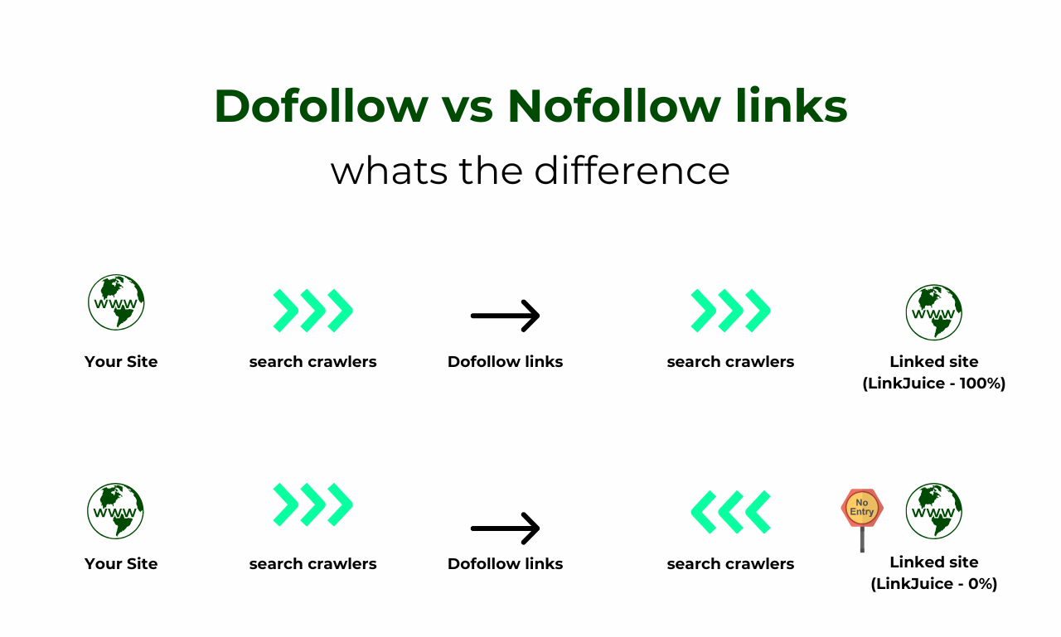

Impact of Each Type on Search Engine Rankings and User Experience:
The nofollow links do not help to improve the ranking of a website on any search engine, but still, they carry great significance.
On the other hand, dofollow links can help drive traffic and make the user experience better by providing additional links.
Also, such search engines as Google over several years can take into consideration the context and the value of nofollow links.

How to Leverage Each Type for Maximum Effectiveness?
To ensure maximum effectiveness, you can ensure that you properly incorporate a dofollow link to build your site's credibility and ranking. These should be earned through quality blog posts, the provision of superior service & products, or personal connections.
On the other hand, no-follow links are good to have on the site and useful for the users, but do not affect SEO.
With the effective use of both types, you can develop an excellent link-building strategy with a healthy blend.

4. 9+1 Innovative Link-Building Strategies for 2025

1. Unearth Internal Linking Opportunities

Strategies for Identifying and Optimizing Internal Links:
Navigation is just one aspect of internal linking and it is a strategy of using link juice and improving UX.
Optimization of internal linkages in the year 2025 is a complex process that involves linking relevant content on a website.
Officially, link building is the process of placing hyperlinks in relevant pages that are closely linked to various relevant and reputable pages.

How to Find the Internal Linking Opportunities?
Below are the procedures to follow to find internal linking opportunities:
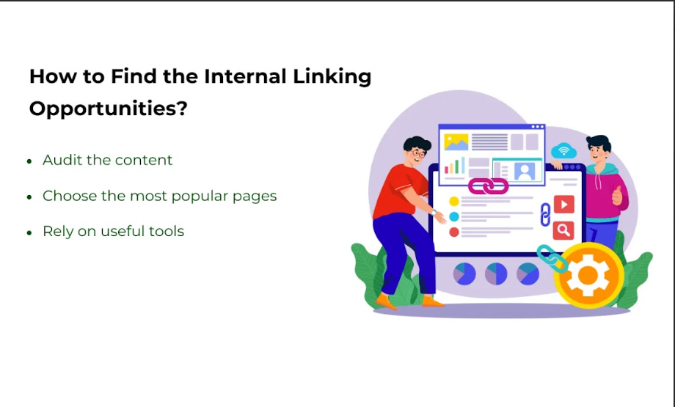
- Audit the content you have currently.
- Choose the most popular pages, which may serve as reference ones, and connect to other pages with a lower rank.
- Rely on useful tools like the Spider tool and Screaming Frog to get an insight into the link structure of a site as well as identify pages that may require more internal links.

How Does Internal Linking Affect Overall Site Structure and SEO?
Proper internal linking adds value to your site hierarchy and enhances the crawlability of your site by the search engines.
It also assists in delegating authority, which in turn enhances the lower-ranking pages on the site.
In this regard, the link contents enhance user experience and engagement, by making the visitors explore more content of your website, by reducing bounce rates.

Tools and Techniques for Effective Internal Linking:
Internal link analysis can be conducted using different tools such as Sitebulb, Link Whisper, and more. These tools can help you to find the broken pages and to determine where they can be connected to other pages. Moreover, you can use plugins focusing on internal SEO like Yoast SEO or Rank Math, which suggest internal linking within the content editor.

2. Capitalize on Broken Links for Backlink Opportunities
This is a way of creating new links. Broken links are associated with linking to pages that were linked to a particular site but do not exist in the current day. This not only assists the site owner in addressing issues but also awards you with a backlink.

Tools to Identify Broken Links on Reputable Sites:
Targeted websites’ broken links can be discovered with the help of such tools as Site Explorer of Ahrefs, Check My Links and Broken Link Checker.
It will be beneficial primarily to concentrate on websites with a high level of domain authority that relate to your field of activity.

How to Pitch Your Content as a Replacement for Broken Links?
Make a proper email message to the administrator or the manager of the site with the description of the problem and your web resource as the solution for the link.
Also, point at the usefulness of the content you are offering as well as a link allowing for quick substitution.
The Relationship strengthening through interaction is a positive way of ensuring that results are achieved.

3. Gain Credibility Through Testimonials: A Subtle Approach
From a communication perspective, using testimonials as a marketing strategy is a subtle approach that builds credibility right from the onset of the selling process.

The Rationale Behind Providing Testimonials for Businesses:
Generally, using testimonials is an efficient way to gain the audience’s confidence. Most of the time when you give your testimonial, you are likely to be given a link back to your site, which acts as link-building.

Steps to Request Links Through Testimonials:
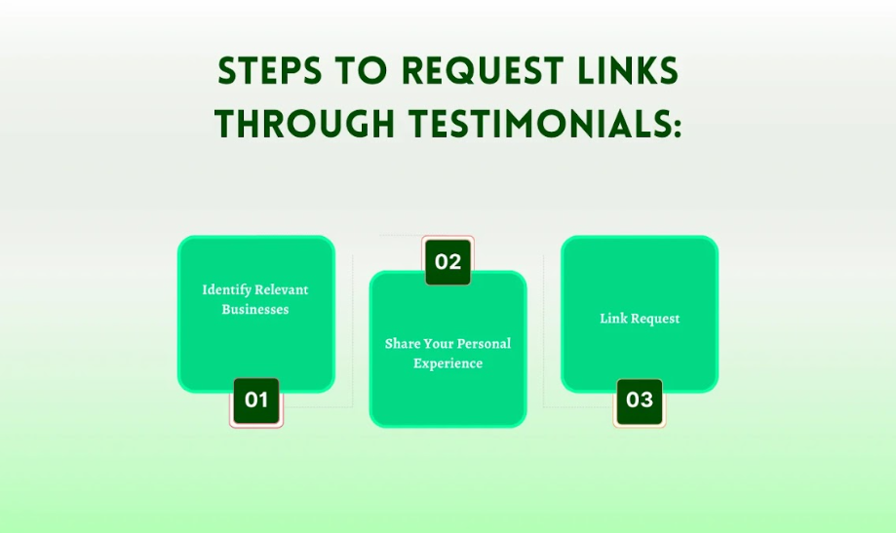
- Identify Relevant Businesses: It is necessary to focus on businesses that are related to your brand or have a similar vision, mission, and target market.
- Share Your Personal Experience: Ensure to state how the product & service were of value to you and if any.
- Link Request: Politely request them if you can have a link to your site where the testimonial will be published.

How to Implement Testimonial Strategies?
The strategies for testimonials have been successful when you consider different aspects.
There are a lot of brands that have been able to use testimonials in link building. For instance, a digital marketing agency in Dubai was using a CRM tool and given a testimonial to write a blog that includes a backlink for that tool.
So, by providing valuable feedback, an agency can ensure that relationships with leaders of the industry are positively reinforced, and multiple linking strategies are materialized.

4. Craft Link-Worthy Content: Building a "Linkable Asset"
The process of creating content to obtain linkbacks requires the development of a linkable asset.

What Constitutes "Link-Worthy" Content in 2025?
Link-worthy content in the future year 2025 will be more valuable because it offers more complete information, an appealing graphical interface, and more relevant content.
So, make sure your link-worthy content reflects what is current in the given field and should contain elements that are rather thought-provoking and that will make people share and link to your content.

Ideas for Creating LLink-WorthyContent:
Here are some ideas on which you can capitalize to create link-worthy content:
- Infographics: To find ideas and samples, use such tools as Canva or Piktochart for creating simple infographics and presenting large sets of data.
- Tutorials: Build extensive tutorials that aim to provide the user with comprehensive information about some aspects of the wiki.
- Defining Characteristics: Offer an option for users to actively participate, such as through quizzes, calculators, or embedded videos.

How to Promote and Distribute Linkable Content Effectively?
Share your linkable assets through social media pages, email subscribers,s and other relevant social-media influencers and journalists in your business sector.
You should consider adding the content you created to the relevant directories and forums.

5. Build or Contribute to Communities: Foster Connections
Through interaction, people create relationships and gain links.
The relationships and links are two basic reasons why pragmatic people started to participate in online communities.
Sharing informative content makes you gain credibility and visitors who can provide you with link juice from forums of such a community.

Platforms to Consider for Community Involvement:
Here are the major platforms you can consider for higher engagement:
- Reddit: Subsequently, be active in relevant subreddits by giving relevant answers and sharing your opinion and knowledge.
- Quora: Establish yourself as a specialist in the field and provide links to your brand products whenever possible.
- Industry Forums: It is advisable to become a member of forums that are related to your line of business.

Strategies for Facilitating Discussions and Obtaining Links:
The main focus of your discussion strategies should be on the creation of value-added rather than the promotion of the self. You can get access to knowledge found from the literature, pose questions that will help other researchers, and provide content that will prove to be of informational value to others. Gradually, as the members come to accept you, you will see that they will source your content as a reference once in a while.

6. The Art of Email Outreach: Building Relationships for Success
Successful email outreach hinges on personalization and value.
Try to find out as much as possible about the recipient. After that, personalize your email in a manner according to the information found.
When sending out emails, ensure that they are short and to the point with the main purpose of promoting your material.
Moreover, also explain in your email how an exchange is good for both of you.

Personalize Outreach Efforts for Higher Response Rates:
You should use a tool such as Hunter.io to look up the contact’s email.
After that, you can write an email introducing yourself and mentioning the latest post or project of the recipient.
Additionally, also explain how your content can be relevant to their platform. Ask them to repost or share your content or invite them to do the same.

Examples of Successful Outreach Emails That Garnered Links:
A good example of a possible first message to send to your outreach list could include the following:
Hello/Hi there,
My name is [name], and I am a [position] at [company/organization/university], primarily focusing on the area of [work focus/interest].
This piece can in turn be achieved by stating a recent article or project of theirs that was in some way helpful and recommending an article of yours that is related or relevant to their work.
Don’t forget to give them an opportunity to engage further with you or interact on a business level.

7. Share Content and Expertise on External Platforms

The Benefits of Guest Posting and Collaboration:
Guest blogging and co-authorship are not only ways to get the links, but the opportunities to share ideas and engage with new audiences. Utilizingg your knowledge on the relevant platforms not only promotes your conten, but also strengthens the connections in the respective field.
Such cooperation may have positive effects for both organizations, such as an opportunity to exchange information and advertise services.

Strategies for Identifying Suitable Platforms for Guest Posting:
The first and foremost approach toward guest posting is outlining the websites that suit your brand and its niche.
First of all, watch the competitors and industry leaders who provide content to understand where it is supplied.
To identify these platforms, using tools like Ahrefs and BuzzSumo will be of great assistance.
This suggests careful consideration of factors such as domain relevance, audience interactions, and content relevance about what you are offering.

Methods of Creating Potent Pitchesforo Website Owners:
Having a great pitch can be a decisive factor between successful guest blogging and failure in it.
While it is possible to submit a generic pitch, it may not yield the best result.
Therefore, it is advisable to mention some of the content that you came across while checking the website and what you can contribute to the blog.
Emphasize on additional findings and give a brief idea about the article that you are planning to write.
It is worth emphasizing that the headline and the text should be brief because website owners receive numerous emails daily.

8. Leverage Keyword Alerts for Real-Time Mentions

Setting Up Google Alerts:
It is vital to keep a check on the latest alerts of the brand in order to engage with the customers.
Have to set up Google Alerts for your brand name and other important keywords to get information when you are discussing online.
You can also rely on advanced features like social mention and forum tracking, which enables you to track specific niche forums and SMM.

Engage with Mentions Rather Than Just Tracking Them:
Simply tracking mentions isn't enough. The real value of such mentions is to actively interact with them in an effort to foster link relationships.
Defensively answer, express gratitude to the individual or organization, and provide further information or opinion if needed.
Ideally, such strategic initiatives go hand in hand with developing brand reputation, which in turn creates more opportunities for cooperation.

How to Turn Brand Mentions into Valuable Backlink Opportunities?
When you have interacted with a mention, try out how you can turn the mention into a backlink.
The next step is to contact the content creator, and offer to add more information concerned with the topic by placing a link to your page.
Offer them an opportunity for an interview. This will help them enhance their article greatly. In this way, it is easy to convince them to give a backlink in return for the value that is being added.

9. Encourage Unbiased Reviews: Building Trust Through Transparency

How Unbiased Reviews can help in gaining Organic Backlinks?
Reviews that have no self-interest are often referred to as gold mines when it comes to organic backlinks.
This is because users who are being honest with their experience always refer back to the site as they express their sentiments.
It also establishes credibility with potential buyers as well as improves the website’s ranking by the connections from various reputable sources.

How to Approach Customers for Honest Feedback?
To get customers to post their reviews, the process should be made as smooth and easy as possible.
As a means of follow-up communication after a purchase, use an e-mail to direct the client to the review page.
It is wise to encourage your consumers to share their opinions by providing an additional bonus or future discounts for people who write feedback.
It is appropriate to avoid subterfuge and lay down the truth in the search for the truth about one’s work.

Strategies to Display Reviews Prominently for Link Generation:
Reviews should be highlighted and placed on your site to extend their effect.
Your website must have a special dedicated page for the reviews that can be accessed through product pages and the homepage.
In case, it is in a blog post or a case study, share snippets from the reviews and the review link should be clickable.
This does not only create shared reviews but also creates more publicity for these reviews, and the chances that other people will link to such reviews are higher.

10. Identify and Leverage Copycats to Build Links
Content duplication is not a rare thing in digital culture.
If you allow others to use the content of your website without permission, it may affect the credibility and reputation of your brand as well as negatively influence the SEO.

Strategies to Reach Out to Copycats and Suggest Backlinks:
When faced with copied page content, it is better not to flag the guilty parties but rather, contact them pleasantly.
Point out the fact of duplication and advise them to link back to your site as a way of dealing with this matter.
Stress the advantages of linking to the authoritative content and how it will benefit the Linking Sites.

How to Protect Your Content While Encouraging Attribution?
While licensing your content, do not forget to state clearly the terms and conditions under which your content can be used as well as follow up on cases of piracy.
Use Copyscape and Google Alerts to identify whether copyright infringements have been conducted or not.
When dealing with copycats, give them a wonderful suggestion: make a few clicks and place a link to the original.
This serves to prevent further duplication while at the same time enhancing identification by the giver and taker of the work.

Conclusion:
Looking into the future towards the year 2025, the link-building strategies must be distinct with respect to the new setup algorithms to follow and the modifying user characteristics.
The link-building analysis is a way to interconnect the pages, test information through broken links, build credibility through testimonial links, link-worthy content creation, nurturing communities, and emails to reach new heights of SEO and significant traffic flow.
That is why at Three Angle Marketing (TAM), we strive to assist you in facing these changes in the market and bring you success in the new digital economy.
Hiring us can facilitate the development and implementation of a strong link-building strategy that can effectively promote your brand in the year 2025 and more.

